_{System Design Document}
_{FeedMe}

_{Client:}
_{Michael Wilson}
_{Team 1:}
_{Giancarlo Mogliazzi}
_{Jessica Ngassa}
_{Kiante Brantley}
_{Minhaz Mahmud}
_{Seth Mosgin}

_{Table Of Contents}

1. Introduction
1.1 Purpose of this document.
1.2 References.
2. System Architecture
2.1 Architectural Design
2.2 Decomposition Description
3. Persistent Data Design
3.1 Database Descriptions
3.2 File Descriptions
4. Requirements Matrix
5. Appendix A - Agreement Between Customer and Contractor
6. Appendix B - Team Review Sign-off
7. Appendix C - Document Contributions

1.Introduction

1.1 Purpose of This Document

The purpose of this document is to describe the system design of the FeedMe website. Key topics covered in this document include the high level system architecture, lower level class designs, and the persistent data design of FeedMe.

1.2 References

2. System Architecture

2.1 Architectural Design

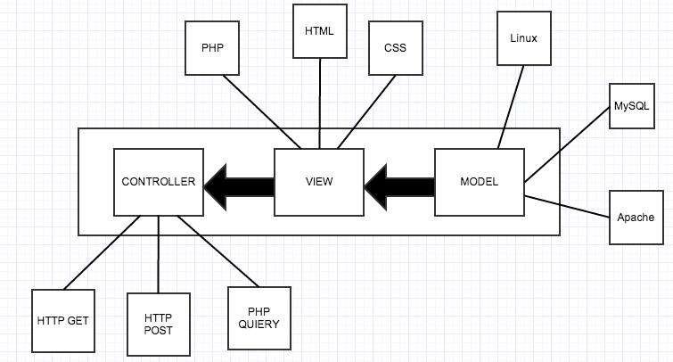

The FeedMe website will be built using the LAMP(Linux, Apache,MySQL, PHP) solution stack. The basic components of LAMP include Models, Views, and Templates, which follows a Model View Controller architecture(MVC).

The model layer consists of the Linux(The operating system),Apache(The web server), and MySQL(The database). All of the data used in our website will be stored on the MySQL server.

The view layer mostly consists of the front-end code involved in the website. HTML and CSS are used to design each web page, and PHP is used to populates the information dynamically into html and then generate the actual html to be sent to the browser.

The controller layer, which talks to the model, would be HTTP GET/POST requests, as well as PHP quieres to our database.

2.2 Decomposition Descriptions

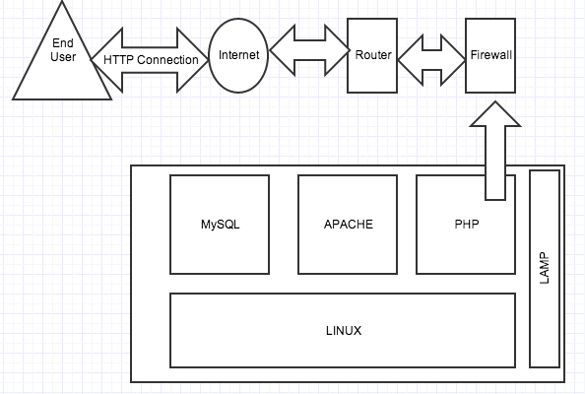

With a LAMP stack, your Operating system, Linux, is the base layer. The other three components are installed on the Linux operating system. Apache, your web server sits on top of your OS. Then, the MySQL database stores all the information served by your webserver(User/Web data), and PHP is used to drive and display all the data, and allow for user interaction. In relation to FeedMe, all of the web pages are dynamic, so PHP scripts send the data from the MySQL database to the website, which will be formatted by HTML and CSS code.

Each time a user is taken to a new page on FeedMe, an HTTP request is sent and a HTTP response and sent back. The Register page currently takes the information entered into the data boxes (Name/Username/Password/Years at UMBC) and is added to a table on the MySQL database. Then, a user can enter those credentials on the Login page and be successfully logged into the site. To accomplish this, the Login page sends a query to out SQL database to see if there is a match for the entered credentials. If the entered information is invalid, the user will be told and the Login process will fail.
In our final sprint (Spiral 3), the search bar will return the result of a query of all the web pages that have to do with the searched tag.

3. Persistent Data Designs

3.1 Database Descriptions

**See DatabaseDesign.pdf**

Users Table
Column | Type | Null
member_id | int(11) | No
email | varchar(64) | No
firstname | varchar(100) | No
lastname | varchar(100) | No
login | varchar(100) | No
passwd | varchar(32) | No

3.2 File Descriptions

Code Description Table
# | File | Brief Description
1 | index.php | Make sure homepage content is displayed properly and all links work
2 | register.php | Frontend for register page for new users Form
3 | registerexec.php | Handles the registration logic for new users, makes sure all fields are valid, escapes all strings, writes to database
4 | login.php | Login form for users (frontend)
5 | loginexec.php | Handles login logic
6 | logout.php | Terminates the login session.
7 | submitReview.php | modal dialog (form) used for submitting a restaurant review
8 | submitReviewexec.php | Handles the logic to submit a review and add it to the database
9 | restaurant.php | Make sure restaurant info is displayed properly and reviews show up
10 | restaurantTimeLine.php | populates the restaurant reviews for a given restaurant
11 | password.php | compatibility library to handle password hashing/verifying
12 | dbconnect.php | creates a database connection
13 | profile.php | Contains the logged in user’s profile information
14 | profileexec.php | Handles the logic for updating a logged in user’s biography
15 | confirm.php | Handles logic for email confirmation for a user
16 | restaurantComment.php | Displays the comments on a particular review
17 | search.php | Handles the search requests and forwards them to the appropriate filters to do the searching
18 | searchrestaurants.php | handles the logic for searching a restaurant and displaying it
19 | searchreviews.php | handles searching for reviews and displays results

20 | searchusers.php | handles searching for users and displays results
21 | moderate.php | php code for flagging and banning
22 | moderatehelper.php | javascript functions to help with moderation
23 | vote.php | php code to handle upvotes/downvotes
24 | css | style sheets
25 | js | javascript files for special functions
26 | scripts | contains php helper functions
27 | img | contains images/icons
28 | fontawesome4.0.3 | font pack for some of our icons

4. Requirements Matrix

Please refer to the System Requirements Specification for details regarding the corresponding use cases.

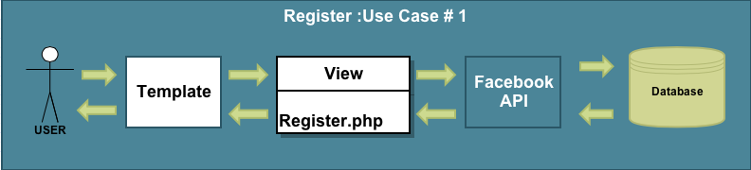
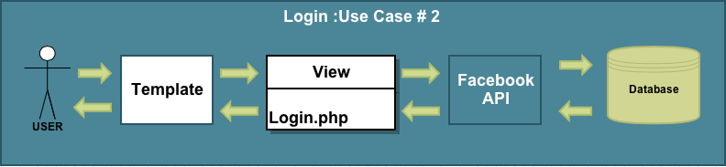
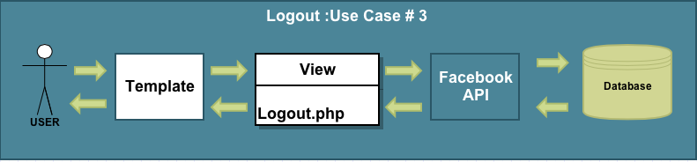
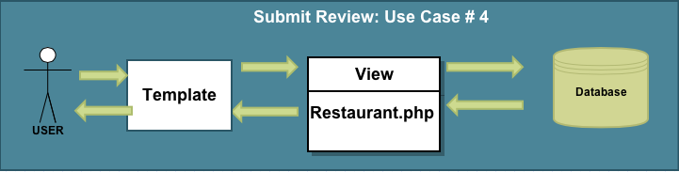
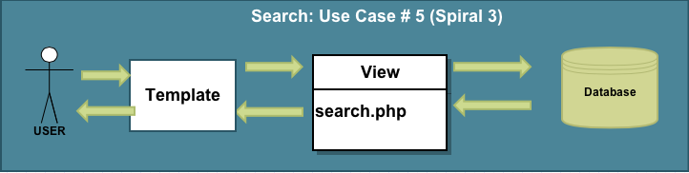
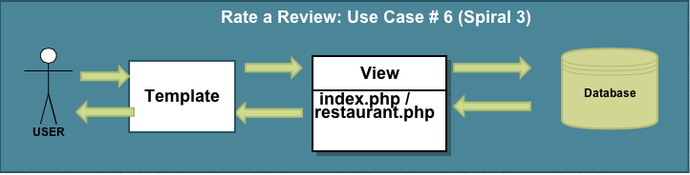
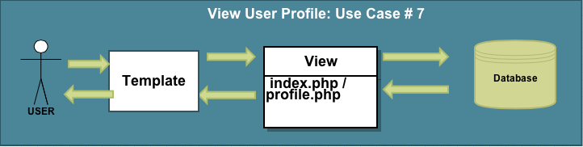

5. Appendix A – Agreement Between Customer and Contractor

By the end of Spiral 1, The customer requested that we have the login and register process/web pages working. See System Requirements Specification for more information. Additional features will be provided in further development spirals.

When and if future changes to this document occur a drafted new document will be created. Both a hard and electronic copy of both versions will be presented to the client for review. Upon approval, the draft will be finalized and signed off by both parties.

Client

Name _________________________________________ Date

___________________ Print

Name _________________________________________ Date

___________________ Signature

6. Appendix B – Team Review Sign-off

All team members have reviewed this document and agree on both the content and the format. Any disagreements or concerns are addressed in team comments below.

Team

Name _________________ Date: 00/00/00

_______________ Print

Name ___________________________ Date: 00/00/00

______________ Signature

Comments:
----------------------------------------------------------------------------------------------------------
Name _________________ Date: 00/00/00

_______________ Print

Name ___________________________ Date: 00/00/00

______________ Signature

Comments:
----------------------------------------------------------------------------------------------------------

Name _________________ Date: 00/00/00

_______________ Print

Name ___________________________ Date: 00/00/00

______________ Signature

Comments:
----------------------------------------------------------------------------------------------------------

Name _________________ Date: 00/00/00

_______________ Print

Name ___________________________ Date: 00/00/00

______________ Signature

Comments:
----------------------------------------------------------------------------------------------------------

7. Appendix C – Document Contributions

Giancarlo Mogliazzi is the owner of this document.
Minhaz Mahmud - added file and database information

